case Scripts:

#!/bin/bash

echo
echo Please chose one of the options below
echo
echo 'a = Display Date and Time'
echo 'b = List file and directories'
echo 'c = List users logged in'
echo 'd = Check System uptime'
echo

read choices

case $choices in

a) date;;
b) ls;;
c) who;;
d) uptime;;
*) echo Invalid choice - Bye.

esac

create a script file

vi case1.bash

Write a script as above

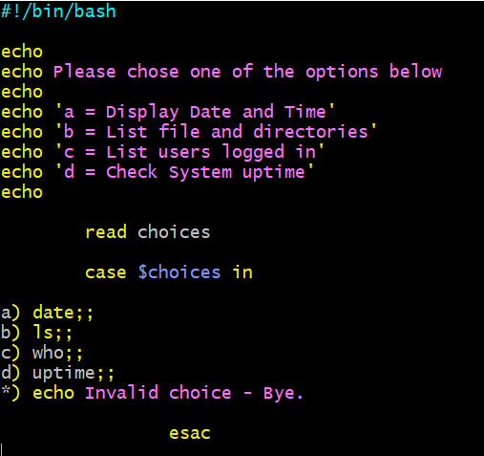
Give permission to script file

Execute the script file

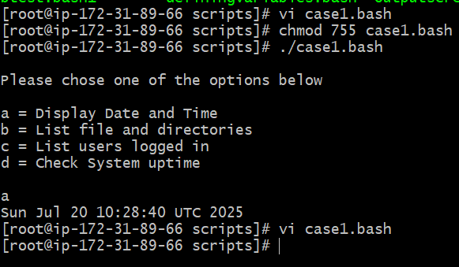

This script will look at your current day and tell you the state of the backup

#!/bin/bash

NOW=$(date +"%a")
case $NOW in
Mon)
echo "Full backup";;
Tue|Wed|Thu|Fri)
echo "Partial backup";;
Sat|Sun)
echo "No backup";;
*) ;;
esac

creat script file
vi casebackup.bash

write a script as above

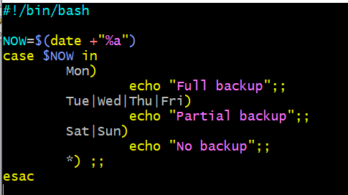

Execute the script

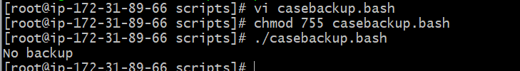

Here the output came as No backup because in the above script it mentioned Tuesday Wednesday Thursday Friday is there
And today is Sunday when you are executing this script so it’s telling no backup

Suppose check by chanhing the script to Sunday Monday Tuesday Wednesday

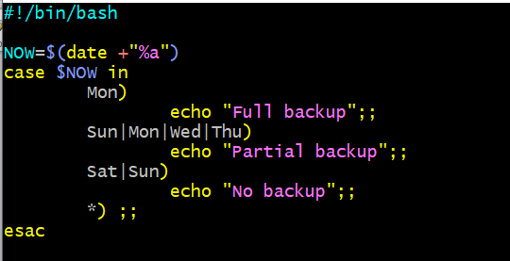

Save it and execute see the output

